Introduction

What is purpose?

Overview

What is protein
50% of dry weight of cells, elements C,H,O,N, usually S, some contain P, Fe, Zn, Cu
amino acids, prosthetic groups, coenzymes, cofactors

Types of protein
classes: nucleoproteins, lipoproteins, glycoproteins, proteoglycans, phosphoproteins, hemoproteins and other metalloproteins, flavoproteins
functions: enzymes (lysozyme, TH), storage (ovalbumin, casein, ferritin), transport (hemoglobin, serum albumin, lipoprotein, transferrin), contractile (myosin, actin, dynein, kinesin), protective (antibodies, fibrinogen, complement), toxins (bacterial: cholera & diphteria, plant, reptilian), hormones (insulin, ACTH, hGH), structural (a-keratin, collagen, fibroin)

Amino Acids
• Review sheet; emphasize structures, stereochemistry

• Other amino acids: rare (4-OH-Pro, desmosine) and nonprotein (beta-alanine, citrulline, ornithine, D-forms)

• Acid-base properties. Isoelectric points

Methods of purifying protein
Separation based on size
tangential ultrafiltration
preparative ultracentrifugation
dialysis
gel filtration
Separation based on charge
Column chromatographic methods
matrix: cellulose, artificial copolymers
ion-exchange:
gel electrophoresis
isoelectric focusing

Separation based on solubility
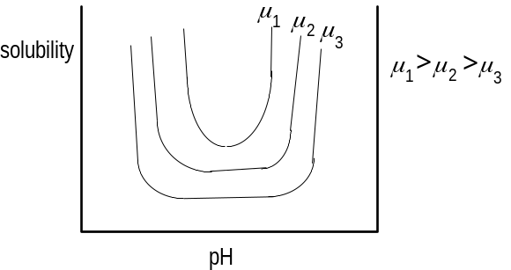
isoelectric precipitation (used rarely)
salting in-salting out
μ=½ Σ cizi2
sphere of influence of charge: 1/b where b obtained from , where ε= dielectric constant of the medium. Hence 1/b ∝ 1/√μ
Separation based on specific affinity or interaction
Hydrophobic interaction
High ionic strength affects water structure, increasing hydrophobicity of proteins
order of tendency to effect the highest hydrophobicity:
anions--PO43–>SO42–>CH3COO–>Cl–>Br–>NO3–>ClO4–>I–>SCN–
cations--NH4+>Rb+>K+>Na+>Cs+>Li+>Mg2+>Ca2+>Ba2+
Chaotropic salts disrupt structure of water, decrease the strength of hydrophobic interactions
Basis of protein binding to HIC column: high ionic strength; elute with low; other factors affecting elution: detergents, temperature, ethylene glycol, pH
Matrix is a Sepharose (usually CL-4B) which is desulfated by alkaline hydrolysis under reducing conditions to eliminate any potential ion-exchange effects in the matrix.
Phenyl-Sepharose is better since strongly hydrophobic proteins not easily eluted with the more hydrophobic octyl-Sepharose. A phenyl ligand is intermediate in its hydrophobicity between n-butyl and n-pentyl. Phenyl ligand binds aliphatic side chains, very likely to bind aromatic amino acids via π-π interactions. If the protein does not bind or elutes early, try octyl-Sepharose, which is good for weakly hydrophobic interactions. Octyl-Sepharose is particularly useful for membrane proteins, since these proteins will still likely bind in the presence of solubilizing concentrations of detergents.
Salts which promote salting out (ammonium sulfate) also promote binding to hydrophobic ligands. Protein samples can be applied in high concentrations of salt such as 1.7 M (NH4)2SO4, 4 M KCl or 4 M NaCl in a buffered solution with pH in the range of 6.5 to 8.0. A 20-30% reduction in binding strength is observed when temperature is reduced from 25° to 4°, so use of a cold room can influence results.
Affinity (ligand) chromatography
Ligand | Specificity
NAD, NADP  Lectins  Poly(U)  Poly(A)  Histones  Protein A  Protein G  Blue F3G-A  Red HE-3B  Orange A  Benzamidine  Green A  Gelatin  Polymyxin  2’,5’-ADP  Calmodulin  Boronate  Blue B | Dehydrogenases  Polysaccharides  Poly(A)  Poly(U)  DNA  Fc antibody  Antibodies  NAD+  NADP+  Lactate dehydrogenase  Serine proteases  CoA proteins, HSA, dehydrogenases  Fibronectin  Endotoxins  NADP+  Kinases  cis-Diols, tRNA, plasminogen  Kinases, dehydrogenases, nucleic acid-binding proteins
If a coupling chemistry is to be done with the ligand to the matrix, the following common chemistries are available:

Linkage | Ligand group | Spacer length | Active pH | Specificity
CNBr | NH2 |  | 8-10 | proteins, peptides
Thiopropyl | SH | equiv. to about 13 carbons | 9-11 | sulfhydryls
Thio | SH |  | 9-13 | sulfhydryls
Epoxy | NH2  OH  SH | equiv. to about 11 carbons | 9  10  11 | proteins, peptides  carbohydrates  sulfhydryls
Tresyl | NH2 |  | 8-10 | proteins, peptides
Aminohexyl | COOH | 6 |  | amino acids, proteins
Carboxylhexyl | NH2 | 6 |  | carboxylic acids
HPLC
Significant difference
reversed-phase
gel filtration
ion-exchange

Methods of determining structure/size

Chemical modification
Relative reactivity
to acylating agents (e.g., iodoacetamide, iodoacetate): Cys > Tyr > His > Lys
to arylating agents (e.g., 2,4,6-trinitrobenzene sulfonate): Cys > Lys > Tyr > His
 | Reacts well to
Cys | mercurials; e.g., p-chloromercuribenzoate  disulfides; e.g., 5,5’-dithiobis-(2-nitrobenzoic acid)  iodacetamide  2-bromoethylamine (modifies Cys to look like Lys which is recognized by trypsin; see J.O. Thomas in Companion to Biochemistry, Bull et al, eds., Vol. 1, p. 87 & 101, Longman, London, 1974).
Lys | 2,4,6-trinitrobenzene sulfonic acid (TNBS)  pyridoxal phosphate (± reducing agent NaBH4)  citraconic acid, malic anhydride (used to modify for limiting trypsin digestion to Arg) (for maleic anhydride reaction, see Butler et al, Biochem. J. 103: 78P, 1967; for citraconic anhydride, see Dixon & Perham, Biochem. J. 109: 312, 1968.)
His | diethylpyrocarbonate  photo-oxidation
Arg | phenylglyoxal  2,3-butanedione
Tyr | tetranitromethane  N-acetylimidazole  iodine
Trp | N-bromosuccinimide
Asp/Glu | a water-soluble carbodiimide + nucleophile (glycine methylester acid)
(for the procedures, see Means and Feeney, Chem Mod of Proteins, 1971.

Notes.
DFP (diisopropylfluorophosphate) shows high reactivity toward only one Ser in chymotrypsin, Ser-195. It does not react with free serine or other serine side chains on the protease. This indicates a super reactivity. Only one Lys (Lys-126) out of over 30 Lys on glutamate dehydrogenase is highly reactive to TNBS. These groups are involved in the active site. But super-reactivity and active site involvement are not always correlated: an especially reactive thiol in creatine kinase is not at all essential to the enzyme’s catalytic activity.
Affinity labeling (using a specially designed super-reactive substrate to bind to the active site and attach (lock) to it. The reaction of bromohydroxyacetone phosphate with triose phosphate isomerase is a good example (De La Mare et al., Biochem. J. 129, 321; 1972).
It is necessary not to believe that a modifying agent causing inactivation is interpreted as the agent binding the active site and hooking on to one of the active site residues. A chemical can react with a residue far removed from the catalytic center, causing some bonding change leading to massive conformational change leading to an inability enzyme to work. Therefore two criteria are minimally necessary to show that the agent is modifying the active site:
(1) There is a direct relationship between inactivation of one active site of the enzyme and the degree of modification in each active site (plots of %enzyme activity vs. #side chains modified per active site from zero to 1.0 gives a straight line with negative slope)
(2) The addition of substrate to the reaction mixture competitively inhibits the occurrence of enzyme inactivation (plots of %activity vs. time of the reaction give at least two lines, one line showing inactivtation occurring with no substrate, and the other lines showing reduced inactivation (smaller negative slopes) with increasing amounts of substrate.
Sanger method of protein structure determination
(a) purify the subunits from multimeric proteins
(b) reduce and alkyalte (2-ME + iodoacetamide) or oxidize (with performic acid) disulfide bonds
(c) N-terminal residue analysis: DNFB or Dansyl chloride
(d) C-terminal residue analysis: either (1) LiBH4, then hydrolyze ---> ident the alcohol; (2) use Akabori procedure: treat with H2NNH2, eliminate hydrazides, C-terminal is underivatized; (3) Carboxypeptidase analysis
(e) Partial hydrolysis or limited or complete digestion
enzymes--trypsin, chymotrypsin, pepsin, thermolysin, elastase
CNBr (E. Gross, Meth. Enzymol. 11: 238, 1967).
(f) separation & analysis
high res. gel filtration
HPLC
electrophoresis
solid-phase chromatography

Do comparative studies of the structure using databases; draw hypotheses

Protein structure

Overview

Primary
amide plane; distribution of charge in ionized amino acids; space-filling models;
wants to form a right-handed twist because of the stereochemistry

Secondary

alpha helix
Pauling & Corey
structure: 0.54 nm pitch/turn; 3.6 res./turn; 0.15 nm pitch/aa; 0.51 nm groove width; 26° groove angle from perpendicular to axis
a-keratins: hair, wool, nails; stretchable in heat; Cys-rich (up to 22%)

beta sheet
Pauling (1951) proposes the antiparallel beta sheet
structure: both parallel and anti-parallel structures
b-keratins: silk, unlike a-keratin, no Cys. Gly-, Ala, Ser-rich

collagen
structure: Gly, Pro, HO-Pro rich; three polypeptides have left-handed twist; wrap around each other in right-handed fashion; repeat motif is Gly-Xxx-Pro or Gly-Xxx-HOPro. Note Pro does not allow α or β sheet. Gly is small and forms inside of
Motifs βαβ loops forming barrel staves

Tertiary
Bernal & Crowfoot (1934) began looking into x-ray crystal structures for protein
First structure: by J. C. Kendrew and co-workers--myoglobin 153 aa; 85% a-helix with 8 helical segments. Function to provide pocket for heme. Fe coordinated to heme + His + O2.to 0.6 nm resolution shows backbone; 0.2 nm resolution shows sec. structure
Phillips looks at first structure of an enzyme
typical formation: (1) compact folding (2) hydrophilic R groups to surface (3) hydrophobic R groups interior
single layer structures usually not in evidence; two layers are necessary to pack the hydrophobic core.

Quaternary

Notes
Anfinsen and White show classic experiment where ribonuclease is denatured and reduced (8 M urea + 2-ME); loss of activity; dialysis; recovery of activity (1° dictates 3°)
Cooperativity aids protein folding so that not all conformation of peptide backbone tried.

Enzymes

Overview

Kinetics

Techniques

Stopped flow technque

Relaxation techniques

Enzyme Regulation

Single enzyme control
Specific inhibitor macromolecules. Examples are trypsin inhibitor
Availability of substrate or cofactors. Examples are cases where [S] differs from Km. [G3P] in muscle is 3 µM whereas Km for G3P dehydrogenase is 70 µM (Oguchi et al, JBC 248: 5571, 1973); changes in [S] clearly affect rate. Other side, [FBP] in mouse brain = 200 µM, but Km of FBP transaldolase = 12 µM (Lowry & Passoneau, JBC 239: 31, 1964).
Product inhibition (sure to see many examples)
Non-enzyme-catalyzed reactions. Example is carbohydrate metabolism, where enzymes show anomeric specificity for monosaccharides in glycolytic path. Glucose phospate isomerase requires α-anomer, but F6P kinase and FBP aldolase need β-anomer. Calculation of rate of α-F6P → β-F6P show it would not be rate-limiting in glycolysis, but β-F6P → α-F6P would be in gluconeogenesis (Benkovic & Schray, Adv. Enzymol. 44: 139, 1976).

Covalent structure changes resulting in activity control.
Examples of irreversible changes in covalent control are activation of zymogens, many of which are proteases. Enteropeptidase (formerly enterokinase) is secreted from the brush border of intestinal cells to activate trypsin, which activates itself and elastase, chymotrypsin, and carboxypeptidases. C1r complement another example of irreversible activation. Most cases of this sort show demonstration of a signal amplification cascade.
Reversible changes in covalent structure include phosphorylation. Phosphorylase b is phosphorylated by phosphorylase kinase on a Ser-14 side chain (needs MgATP) and deactivated by hydrolysis of phosphate ester (see rev. in Fletterick and Madsen, Ann. Rev. Biochem. 49: 31, 1980). The phosphorylation of Ser-14 is now known to make it interact with Arg-69, making the once flexible N-terminal of the first 19 amino acids more constrained.

Ligand-induced conformational changes
Experiments on regulatory enzymes in multistep biosynthetic pathways demonstrates this. AMP was found to be required for muscle glycogen breakdown (Cori et al, JBC 123: 381, 1938). Isoleucine, although it had little resemblance to the substrate or its product, inhibited the first step in its biosynthesis in E coli, threonine dehydratase, which converts threonine to 2-oxobutyrate (Umbarger & Brown, JBC 233: 415, 1958). Also in E coli, CTP was found to inhibit aspartate carbamoyltransferase whereas ATP was activating (Gerhart & Pardee, JBC 237: 891, 1962).
Monod, Changeux and Jacob outlined these events in a classic review (J Mol Biol 6: 306, 1963). Several things are noted.
(1) ligands did not resemble substrates or products and unlikely to bind active site, and was shown true in that inhibition kinetics was mixed-type, not classically competitive, NC, or UC.
(2) the enzymes regulated do not show classical M-M hyperbolic velocity increases, but rather sigmoidal v vs. [S] curves.
(3) These enzymes could be treated in ways to make them insensitive to the effector but do not lose catalytic activity; for example, ATCase can be heated and still catalyze by not be inhibited by CTP. The resulting kinetics of the desensitized enzyme is now hyperbolic instead of sigmoidal.
(4) Most of the enzymes of this class are oligomeric.

Models of regulation
The following models will be discussed: A. V. Hill, J. Physiol. 40: iv (1910); G. S. Adair, J. Biol. Chem. 63: 259 (1925); Monod, J., Wyman, J., Changeux, J.-P., J. Mol. Biol. 12: 88 (1965); and Koshland, D. E. Jr., Nemethy, G., Filmer, D. Biochemistry 5: 365 (1966). Other models which could be referred to are Rabin, B. R. Biochem. J. 102: 22C (1967) and Ferdinand, W., Biochem. J. 98: 278 (1966).
The Hill equation. Hill put forth the equation

where Y represents the fractional saturation of a ligand A binding to a ligand-binding molecule P, and K is the dissociation constant (= [P] [A] / [PA]). Plots of Y vs [A] show this equation to be sigmoidal. If we assume P has n binding sites, and the binding of A is extremely cooperative, we can express this by:
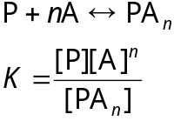

Examples of protein structure/function

Chymotrypsin
A protein hydrolase found in pancreatic acinar cells in its zymogen form. It is activated in stages in the gut as follows (see GP Hess, The Enzymes, 3rd Ed., vol. 3, 213; 1971): (1) trypsin hydrolyzes the R15-I16 bond of chymotrypsinogen to create π chymotrypsin, which is now fully active; (2) chymotrypsin itself induces a further “maturation” by cutting π chymotrypsin at L13-S14 to form δ chymotrypsin; (3) chymotrypsin continues to cut twice more at Y146-T147 and N148-A149 to form α chymotrypsin. The α chymotrypsin form is therefore made up of 3 chains (A, B, C) connected by 5 disulfide bonds. MW=25,000. It catalyzes amide and ester bond hydrolysis of polypeptides and analog substrates. For amides, which are much less reactive than esters chemically, substrate specificity is for large hydrophobic side chains (Tyr, Trp, Phe, then Leu and Met to a lesser extent). Hydrolyzed esters show less specificity probably because they are quickly prone to hydrolysis.

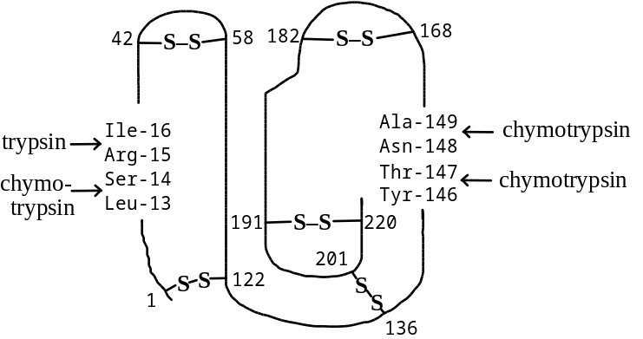
Chymotrypsin structure shows extensive antiparallel β-sheet with some helical content. Some charged groups, namely the and side chain COO– of Asp-102 and Asp-194 are buried in the interior (see DM Blow, The Enzymes, 3rd Ed., vol. 3, 185; 1971). In the activation of chymotrypsin, the newly formed α-amino group of I-16 moves toward the COO– side chain of D-194, causing a large conformational shift which actually opens the entrance for the substrate by parting Arg-145 and Met-192. There is in fact little movement of the active site side chains which are already in their proper orientations in the zymogen.
The hypothesis of the interaction between I-16 and D-194 shown by x-ray diffraction data was helped by a study in which (1) all α- and ε-amino groups of the enzyme were acetylated with Ac2O of the zymogen chymotrypsinogen prior to trypsin treatment to activate the enzyme; and then (2) showing that addition of [14C]Ac2O to acetylate the newly created α-amino group on I-16 correlated radioactive incorporation with enzyme inactivation (see GP Hess, The Enzymes, 3rd Ed., vol. 3: 213, 1971)
DFP inactivation studies indicated that Ser-195 was modified. The x-ray crystal data indicates the proximity of Ser-195, His-57, and Asp-102 in the active site cleft: from this data, a charge relay to make the enzyme reactive to its substrate was proposed (see Blow et al., Nature 221: 337, 1969). In the figure, Asp-102 lies in juxtaposition to His-57, abstracting a proton which then abstract or at least polarizes Ser-195 hydroxyl group such that a high degree of basic character is induced. Its proximity to the polarized carbonyl C of the protein amide bond allows nucleophilic attact to form the intermediate acyl enzyme. This is actually the fast step in the catalysis. One peptide bond cleavage is achieved, water must come in to begin deacylation to restore Ser-195. With nonprotein ester substrates, this step is quite slow compared to transacylation; with proteins however, the deacylation is comparatively rapid, probably because breaking the amide peptide bond is not very easy.
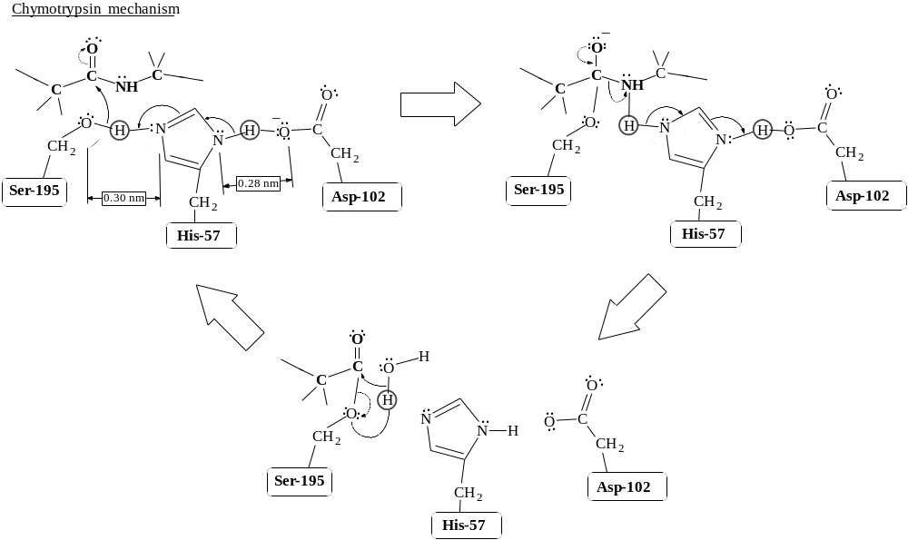
Note that the diagram does not reflect the true spatial relationship in the 2-dimensional schematic. It is possible that there is torsional strain on the peptide backbone at the point of the carbonyl carbon.
Other features of catalysis--From experiments done using the substrate analog N-formyltryptophan (see Steitz et al, J Mol Biol 46: 337, 1969): (1) the amino acid side chains forming the substrate binding pocket in proximity to the R side chain are composed of nonpolar amino acids; (2) the nonbonding electron pairs of the carbonyl O can form a hydrogen bond with the H of the Gly-193 nearby or with the H of Ser-195, whose proton is likely abstracted by the His-57 side chain; (3) the H of the amide function can bind to one of the nonbonding pairs of O on Ser-214 side chain.

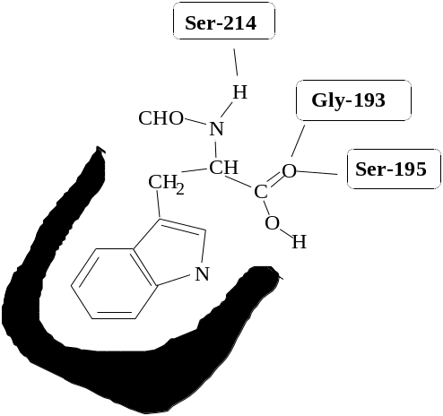

Comparison of the substrate binding pockets of chymotrypsin, trypsin, and elastase might explain their specificity. Note elastase can only accomodate small groups (e.g., Ala), while trypsin prefers cationic side chains (Lys, Arg).

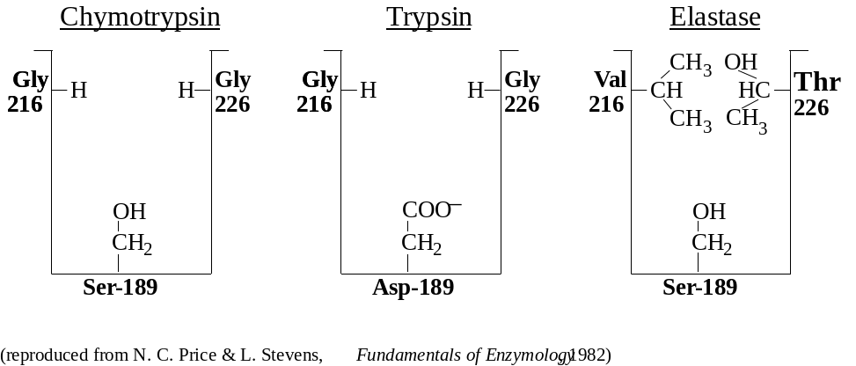
Catalytic intermediates of chymotrypsin proving the mechanism involving an acyl intermediate on Ser-195 were done using studies with various high concentrations of amide [H2NCH(CH3)CONH2] (see Fastrez and Fersht, Biochemistry 12: 2025, 1973). In the normal catalytic completion, the Ser-195 acyl intermediate is hydrolyzed by water in the aqueous environment, but other nucleophiles (such as the primary amine of alaninamide) can compete as better nucleophiles.
Comparison of the chymotrypsin mechanims can be made to carboxypeptidase A. Two types of carboxypeptidases, A and B, are similar in their structure and activity but are distinguished by the fact that carboxypeptidase B is specific for removal of C-terminal Lys or Arg residues (its Asp-255 side chain is suitably positioned to attract these residues). The metalloenzyme carboxypeptidase A is similar to chymotrypsin in that it has a means to polarize (with the zinc atom) and thereby activate the carbonyl group to nucleophilic attack. The Tyr-248 residue may act as a proton donor in this respect. Note that Arg-145 is positioned to stabilize the COO– terminus. (see Fersht, Enzyme Structure and Mechanism, ch. 12, 1977; Quiocho & Lipscomb, Adv. Prot. Chem. 25: 1, 1971).

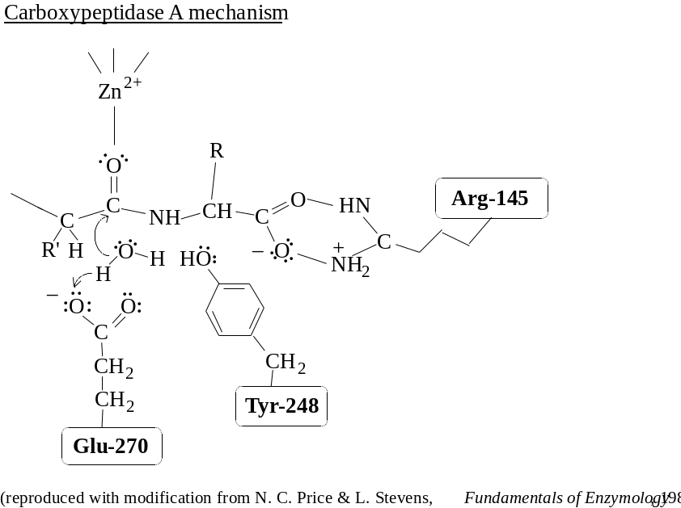
Additional notes by J. Kraut in The Enzymes, Vol. III, pp. 165-183
Latest data based on the x-ray data studies by Freer et al, Biochemistry 9: 1997 (1970) at 2.5 A resolution. These studies show a current activation scheme:
The zymogen can take two paths. Path 1 (slow activation pathway): zymogen is digested by active chymotrypsin to remove dipeptide 147-148 to form neochymotrypsin; this is then cut by trypsin to remove dipeptide 15-16 to form the α-chymotrysin (fully processed). Path 2 (considered the normal, fast pathway): zymogen is cut by trypsin to remove dipeptide 15-16 to form π-chymotrypsin, then cut by chymotrypsin to form δ-chymotrypsin, cut again to form a γ-chymotrypsin, which is a conformational variant in equilibrium with α-chymotrypsin. It is observed that Arg-15 faces the exterior for easy attack by trypsin; The other Args (at 145, 154, and 230) are all in surface crevices and inaccessible to trypsin.

Triosephosphate isomerase
Converts glyceraldehyde-3-phosphate (G3P) to dihydroxacetone phosphate (DHAP). Keq=367 at 25° in favor of DHAP formation. kcat = 2.5 × 105 min–1. Enzyme is homodimer with total MW 53,000.
X-ray diffraction data show a “perfectly evolved enzyme.” Subunit is spherical in shape with 3.5 nm dia. Subunit forms an inner cylinder composed of 8 staves formed by parallel β-sheeting between strands. The bottom end of one stave loops around the outside in a helix to start the top of the next stave. There are also some large sequence in the outer loops of some staves. The contact area between subunits is rich in polar amino acids. The amino acids which are found to be within 4 Å of the substrate in 3-D structure studies with DHAP-TPI are Glu-165, Ser-96, His-95, Glu-97, and Lys-13. (Banner et al, Nature 255: 609, 1975; Phillips et al, Biochem. Soc. Trans. 5: 642, 1977)
Isotope labeling studies using 3H2O show a recovery of [3H]DHAP on the C3 carbon, suggesting that a base-catalyzed reaction producing a cis-enediol intermediate is the mechanism by which the enzyme works. This was verified by adding [3-3H]DHAP to TPI in normal buffer containing NAD+, glyceraldehyde-3P dehydrogenase, and arsenate. (G3P-DHase is added to convert and “trap” and G3P formed into the glycerate; NAD+ and Pi are required, but arsenate is substituted for Pi so that the unphosphorylated glycerate is quickly formed and does not perturb G3P-DHase). 5% of the glycerate formed had label incorporated at the 2-C, suggesting stereospecific base-catalysis, since another mechanism involving more than one base would give virtually no label. The showing of a 95% loss shows some proton exchange of the solvent with the base amino acid side chain is occurring. (Knowles and Albery, Acc. Chem. Res. 10: 105, 1977)
2-Phosphoglycollate is a strong competitive inhibitor (Ki= 6 µM) of TPI and is believed to resemble the transition state cis-enediol intermediate of the enzyme, which may be additional evidence of the mechanism
The substrate analogues bromohydroxyacetone phosphate (BHAP) and glycidol phosphate appear to be excellent affinity labeling compounds for TPI, and both are in fact quite reactive to nucleophilic attack resulting in covalent bonding to the enzyme (De La Mare et al., Biochem. J. 129, 321; 1972; Miller and Waley, Biochem J. 123: 163, 1971).

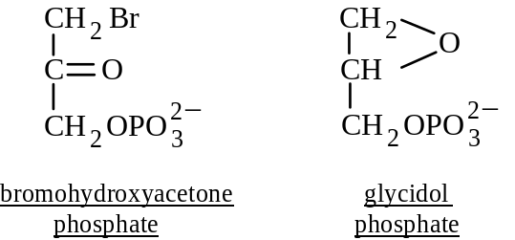
Sequencing of peptide containing the modified amino acid revealed that Glu-165 was modified and hence was the nucleophile involved in catalysis. In the case of BHAP, it was possible for the attached label to migrate to the adjacent Tyr-164, suggesting a role for it in catalysis; the migration could be prevented by subsequent reduction with NaBH4.
The mechanism of TPI catalysis now appears to be Glu-165 nucleophilic attraction to the proton on 2-C of G3P with subsequent rearrangment of bonds to form a cis-enediol. In a second step, one electron pair forming the C=C double bond migrates to C-1 to take back the proton given to Glu-165; the bond in which H attaches to O of the C-2 hydroxyl is then used to stabilize the resulting carbocation, forming the ketone. This proton may then migrate to the O atom on C-1 to form the hydroxyl.
Unanswered questions related to the mechanism:
(1) Perhaps the most important question: what electrophilic group on the enzyme polarizes the carbonyl group on the aldehyde to make it reactive, a chemistry surely necessary? There is both chemical and IR spectroscopic evidence of C=O polarization (Webb and Knowles, Biochem J. 141: 589, 1974; Belasco and Knowles, Biochemistry 19: 472, 1980).
(2) What is the role of His-95 as 3-D information shows it to be in the active site? Is it involved in the proton transfer between the O atoms of the hydroxyl and carbonyl functions?
(3) What positively charged residue is involved in binding the phosphate group?

Fructose-1,6-bisphosphate aldolase
Catalyzes the aldol condensation of DHAP to an acceptor aldehyde; usu. the acceptor is G3P in glycolysis. FBP aldolase is divided into a Class I (Type I) enzyme, which comes from higher plants and animals and which uses a Lys at the active site, and into Class II (Type II), which is found in bacteria and fungi and uses a metal ion at the active site.
The Class I enzyme is further subdivided in mammals into three tissue-specific isoenzyme which differ with respect to their activity toward either FBP or fructose-1-phosphate (F1P). Isoenzyme 1 (type C) is found in the brain and shows a FBP/F1P reactivity of 26:1. Isoenzyme 2 (type A) is found in muscle and show a 50:1 FBP:F1P reactivity, which is typically since it is usually never in contact with F1P. Isoenzyme 3 (type B) is a liver enzyme with 1:1 FBP:F1P reactivity, since it must metabolize both FBP and F1P. (Lai & Horecker, Essays Biochem. 8: 149, 1972; Lebherz & Rutter, Biochemistry 8: 109, 1969)
Rabbit muscle FBP aldolase exists as five IEF-resolvable species which show it to be a heterotetramer (MW=160,000) assembled as all possible combinations of two subunits, α and β (i.e., α4, α3β, α2β2, αβ3, β4). The α and β subunits differ by only one amino acid at the C-terminal sequence (α = -Asn-His-Ala-Tyr, β = -Asp-His-Ala-Tyr), and it is known that α converts to β, showing the Asn residue is hydrolyzed to form the Asp. X-ray data shows that the four subunits do not form a tetrahedron but are arranged in pairs of dimeric units (Eagles et al, J Mol Biol 45: 533, 1969). Protein sequence data is known (Lai, Arch Biochem Biophys 166: 358, 1975) in which the subunits have about 360 amino acids.
The kinetic work was done by studying isotope exchange of DHAP in 3H2O medium, varying the G3P concentration (Rose et al, J Biol Chem 240: 1758, 1965). This showed the enzyme to follow an Ordered Bi Uni mechanism, with DHAP required to bind followed by G3P on the Bi side.
Trapping experiments using NaBH4 reduction of enzyme mixed with either 14C- or 3H-labeled DHAP showed both loss of activity and incorporation of label. A Schiff base was clearly formed between a Lys side chain amino group and C=O of DHAP, easily reduced. The 18O-labeled carbonyl of DHAP also is found in water, indicating a Schiff mechanism (Model et al, Biochemistry 7: 1339, 1968). Lys-227 appears to be the amino acid bound to DHAP. Formation of the Schiff base intermediate is more electron-withdrawing than just a carbonyl oxygen for the purpose of achieving aldol condensation.
Another study using pyridoxal phosphate followed by reduction with NaBH4 led to enzyme inactivation yet DHAP was still able to bind the enzyme, suggesting the involvement of another lysine in the active site (Shapiro et al, Arch. Biochem. Biophys. 128: 554, 1968). The modified lysine was found to be Lys-107. It is proposed that this lysine actually interacts ionically with the phosphate of DHAP to help position the C2 carbonyl for Lys-227 action.
FBP aldolase is photo-oxidized in the presence of Rose Bengal, suggesting the involvement of histidine in catalysis as well (Hoffee et al, Proc. Natl. Acad. Sci. USA 57: 107, 1967). Since too many histidines were modified by this treatment, N-bromoacetylethanolamine phosphate (BrCH2CONHCH2CH2OPO32–) was used in a semi-affinity-labeling study. This resulted in the alkylation of single histidine per subunit, His-359 (Hartman & Welch, Biochem Biophys Res Comm 57: 85, 1974). It is proposed that the His-359 may be involved in proton transfer by first losing a proton to an adjacent basic element (as in chymotrypsin), then abstracting a proton from C1 of the bound and Schiff base intermediate of DHAP to form the carbanion which is nucleophilic to the aldehyde carbon.
Although 3-D structure data was not available at the time of the work, other amino acids are thought to play a role as catalytic or substrate-binding side chains. Arg-55 and/or Lys-146 is thought to stabilize the DHAP phosphate group (Ogata et al, Biochim Biophys Acta 742: 384, 1983). Chemical modification studies indicate involvement of tyrosine and cysteine side chains. It is of interest to know whether FBP binds in the ring (furanose) form or whether it is an open (keto) sugar; normally <2% of FBP in solution is in keto form, while a majority of the furanose form is the β anomer.
The rabbit muscle FBP aldolase is probably an excellent paradigm of other class I FBP aldolases since structural homology is quite high for the active site sequences. Class II aldolases do not depend upon lys but instead use a metal (Zn2+) to achieve the necessary polarization of the C=O oxygen, thereby making one of C-1 protons suitably acidic for a base accepting side chain (which is probably Glu or Asp rather than the His used by class I enzyme). Yeast FBP aldolase is a dimer which contains one Zn2+/subunit.
Littlechild and Watson (1993) TIBS 18: 36-39 have used computer-analyzed data to propose a different mechanism for the action of FBP aldolase. Work done earlier indicated the involvement of a Cys, His, a second Lys, and a COOH-terminal Tyr in the catalytic events. Horecker et al. (The Enzymes, Vol. 7, P.D. Boyer, ed., pp. 213-258) had proposed a model whereby the Cys mediates transfer of a proton from the C-4 carbonyl hydroxyl to the side-chain nitrogen of the second Lys residue. The His residue is believed to provide a proton to release the enamine intermediate, and Tyr is supposed to provide the conformation required for interaction between the Cys and Lys. The problem is that Cys is not at all located near the active site cavities, according to x-ray diffraction data (Sygusch et al., PNAS USA 84: 7846-7850, 1987). Hori and coworkers have extended the x-ray data by showing that mutagenesis of aldolase to substitute with Ala the two proposed active site Cys residues at 72 and 338 in the human A enzyme did not affect the enzyme activity when compared to wild-type.
Three type I aldolase subunit primary structures which have been determined (rabbit: Sygusch et al.; human: Gamblin et al., FEBS Lett. 262: 282-286, 1990; D. melanogaster: Hester et al., FEBS Lett. 292: 237-242, 1991) show considerable homology. All are tetramers with near, or exact (human enzyme), 3-fold axis symmetry. The intersubunit contact areas show the same structure in all three enzymes. Subunit structure is the beta-barrel type surrounded by alpha-helical and random coil interconnecting loops. The consensus structure suggests this is true for subunits for all species. Residues assumed to be involved in substrate action are directly or indirectly conserved, and this includes residues thought to be particularly involved in substrate binding. The side-chain of Schiff base-forming Lys (Lys-229 in human type I) is oriented toward the center of the 8-stranded beta-barrel. The alpha-helix on the amino terminus prevents access to the active site from the amino end of the beta-barrel. The COOH-terminus residues traverse the rim of the open-end of the barrel.
Residues involved in substrate binding belong to four categories: (a) those involved in shuffling protons in either abstraction or donation, (b) those interacting with C-1 phosphate, (c) those interacting with C-6 phosphate, and (d) acidic residues which serve to produce a neutral electrostatic potential around the active-site cavity. The Schiff base-forming Lys has its epsilon-amine side chain running parallel to the beta-barrel axis, pointing to the floor of the active site cavity. Its environment is suitable for the uncharged, more basic amine group. A proton is expected to transfer from this Lys in the Schiff base formation to the C-2 carbonyl oxygen to form the carbinolamine. A 2nd Lys is positioned to collect the remaining proton from the side-chain nitrogen of the Schiff-base forming Lys. (see figure 2).
The catalytic cycle can be envisioned as starting with binding of either FBP or DHAP (in the case of gluconeogenesis). The cycle will be described in terms of neogenesis using the human A enzyme numbering. DHAP binds in the active-site cleft, in which the uncharged amine of Lys-229 adds to the carbonyl; the temporary carbinolamine is formed by movement of an amine proton to the carbonyl oxygen. The more stable imine form is made when Asp-33 donates a proton to the C-2 -OH group, making it a good leaving group. In the formation of the enamine from the imine, a second Lys (Lys-146) must be in position to donate a proton to the Schiff base nitrogen of Lys-229. At the same time, a proton on C-1 must be removed. In some isozymes this C-1 proton is removed by a C-terminal Tyr brought into position after the substrates bind. (In less catalytically active enzymes, water seems to serve as the proton acceptor.) The fully protonated Tyr phenolic oxygen shows one of its nonbonding pairs to the C-1 proton. As it accepts the C-1 proton, the proton already bound to it is positioned such that it is transferred to the C-1 carbonyl oxyen on G3P, thereby activating G3P toward a condensation.
The necessity of carboxyl terminal residues in the catalytic activity of rabbit muscle aldolase was shown long ago when carboxypeptidase was found to inactivate the aldolase. It was a surprise when Hori and coworkers showed not a loss, but decrease in activity when Tyr was replaced with Ser. The B enzyme, moreover, does not require Tyr at all, losing no activity when its C-terminal Tyr is replaced. His-361 in the human A isozyme is observed to interact with both the 1-phosphate and the -COOH group of the C-terminal residue. These interactions serve to orient the Tyr residue relative to the substrate. The phenolic hydroxyl is positioned to abstract a proton from DHAP and provide the one it already has simulateously to G3P. For the B enzyme, there is no His group to assist the Tyr-mediated proton channeling; for mutant A isozyme in which Ser replaces Tyr, the effect is the same. The reason there is no loss of activity is that water serves as the acceptor and donator, albeit much less efficiently.
Even before their x-ray structures showed the position of both Lys residues in the active site, chemical modification studies had already shown their importance. Aldolase which had been incubated with [14C]DHAP was treated with NaBH4. Alkylation of Lys-146 with N-bromoacetylethanolamine phosphate completely abolished the activities of both FBP aldolase and transaldolase, and it was surmised that it was involved in binding the phosphate group of the substrate (it is). Used at pH 6.5, this affinity label modifies His residues; it modified a His which was two residues away from the C-terminal Tyr. It was found that when His was alkylated, the Lys could not be, and that when Lys was alkylated, His could not be; this supports the mechanism proposed for catalysis.
In this entire mechanism, there is no role for any Cys residues, as originally proposed.

Lactate dehydrogenase
Catalyzes reversible conversion of lactate and NAD+ to pyruvate and NADH and a H+. The enzyme concentration in cytosol is so high that the reaction is close to equilibrium. Although many sources have been studied, details of structure are from dogfish and pig (Holbrook et al, The Enzymes, 3rd ed. 11: 191, 1975 gives compreh. review). LDH is heterotetramer with total MW 140,000, with various combinations of an and β subunit, which are predominantly heart or muscle subunits, and therefore designated H or M instead of α and β. Other isoenzyme forms (C, E, and F) are known.
Kinetic studies using substrate binding and product inhibition analysis show an Ordered Bi Bi addition sequence: the dinucleotide must bind first and be released last, while the 3C molecule must wait. Hence NAD+ binds before lactate, and after conversion, pyruvate leaves before NADH. Steady state kinetics shows that oxamate is a competitive inhibitor of pyruvate (note they are isoelectronic) and oxalic acid is competitive with lactate.
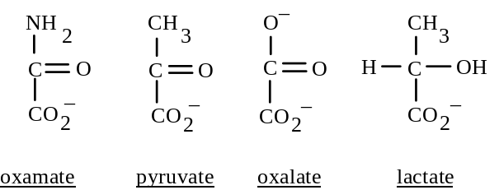
Stopped-flow kinetic analysis using spectrophotometric monitoring of NADH has enabled the determination of rates of each step of the reaction (Heck et al, Biochem J. 108: 793, 1968). When the data is expressed as a plot of NADH production (# mol product/mol active site) against time in the first 15 ms, there is observed an initial burst of NADH produced within instrument dead time, i.e., at t=0 ms, plot crosses at near 1 mol NADH/mol active site instead of at 0. Hence, all steps up to NADH formation are rapid. With the pig M4 isoenzyme, this was also true, but was clearly pH-dependent: at pH >= 8.0, the burst was 1 mol NADH/mol active site but at lower values the burst was less (~0.5 mol product/mol active site) (Stinson & Gutfreund, Biochem. J. 121: 235, 1971). Although NADH binds tightly and release of product would be expected as a rate-determiner, dissociation has rapid k = 450 s–1 compared to steady-state rate of lactate oxidation (k = 80 s–1). From the data, another step is believed to be the rate determiner which comes between the oxidation step and NADH release, and this is believed to be a conformational change in the E-NADH or E-NADH-pyruvate complex. Pig H4 rate constants for all steps are known (Südi, Biochem J. 139: 251 & 261, 1974).
X-ray diffraction patterns for M4 of dogfish (see Holbrook et al) show secondary structure to be 40% helical and 23% β-sheet. In the N-terminal half is a 6-stranded parallel sheet, while in COOH half are two 3-stranded antiparallel sheet structures. The 6-stranded sheet is the NAD+-binding region and this structure is a feature of all nucleotide dehydrogenases and enzymes with mononucleotide substrates, e.g. kinases binding ATP. Note in the diagram that the stretch of amino acids between c and d is a nonhelical stretch. The nicotinamide ring of NAD+ binds between strands d and e while the adenine ring binds to between strands a and b.

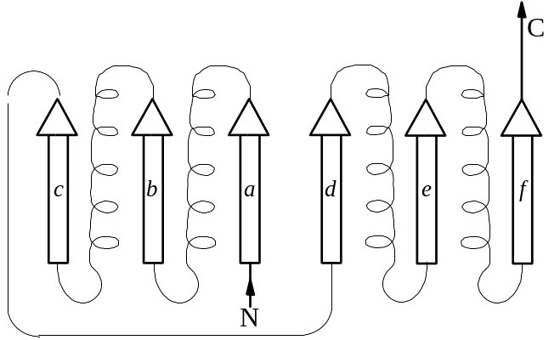
The amino acids of LDH shown involved in the binding of the NAD+ molecule are depicted in the diagram. It should be noted that the specific interaction of Asp-30 and Lys-58 with the adenine ribose 2’-OH group explains why NADP+, which has a phosphate at this position, does not bind. (Glutamate dehydrogenase is unique in that it can interact with either NAD+ or NADP+.)

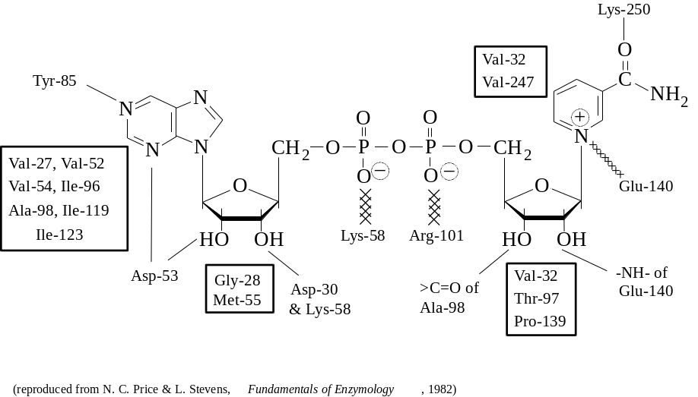
The hydrogen bond between the carbonyl amide of nicotinamide and Lys-250 serves to orient the ring in a way that either an “A-side” or “B-side” hydrogen is abstracted. Certain dehydrogenases are “A-side,” e.g., malate, lactate and alcohol dehydrogenase, while others are “B-side” types, e.g., glutamate and glyceraldehyde-phosphate dehydrogenases. The B-side specificity of the dehydrogenase shows interaction with Asn-313 and the nicotinamide carbonyl oxygen, causing B-side interaction with the substrate (Biesecker et al, Nature 266: 328, 1977; Moras et al, J Biol Chem 250: 9137, 1975).

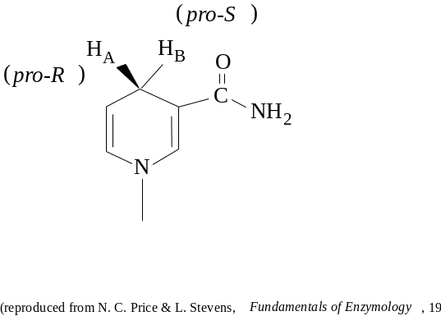
From examination of enzyme complexes with inhibitors and substrates, viz. E-NAD+-pyruvate, E-NAD+-lactate, E-NADH-oxamate, and E-(NAD-pyruvate adduct): this shows that lactate is most probably situated between the nicotinamide ring and His-195, with its -COO– group stabilized by Arg-109 and Arg-171. The His-195 serves to remove a proton from the C-2 OH group to be oxidized, with electron movements and the C-2 proton being “grabbed” by the nicotinamide ring suitably positioned (Adams et al, PNAS 70: 1968, 1973). Conformational movements (discussed as being the slow step in the kinetic mechanism) are crucial in forming the catalytically active complex. After lactate binds to the E-NAD+ complex, a loop encompassed by residues 98-120 is in large contact with the solvent prior to any substrate binding but closes around the substrates to exclude water from the active site. A 1.4 nm (!) translocation of Arg-109 toward the substrate is one such identified movement, while the catalytic residue His-195 is brought 0.1 to 0.2 nm closer to substrate to start the catalytic event (see Adams et al).
Chemical modification studies were useful in providing evidence of the action of some residues.
• Affinity labels 3-bromoacetylpyridine and bromopyruvate are substrate analogues, both of which were found to react with His-195. Diethylpyrocarbonate also selectively modified His-195, showing its greater reactivity compared with other histidines in the subunit (Holbrook & Ingram, Biochem J. 131: 729, 1973). All modifications inactivated the enzyme.
• Phenylglyoxal reacted with one Arg/subunit, cauing inactivation. This inactivation was prevented when the enzyme was incubated with substrates to form ternary complexes. The crystallographic data indicates that two Arg are located within the substrate-binding region, but the phenylglyoxal-modified Arg has not yet been identified.
• LDH was modified and inactivated with treatments with substituted maleimides, implicating cysteine involvement. One cysteine per subunit is modified, shown to be Cys-165 (Taylor et al, PNAS 70: 1790, 1973). Although addition of substrates prevented inactivation and the high amino acid sequence conservation encompassing this Cys in other dehydrogenases suggested its importance, the x-ray crystal data showed it to be at least 1 nm from the substrate binding region. The interpretation is that the bulky reagent modifying this Cys-165 is a steric hindrance toward the conformational movement of His-195 toward the substrate during the catalytic event; protection against modification by a ternary complex of E-NAD+-pyruvate would block reagents from approaching Cys-165. In light of this study, it was proposed that a less steric modifying reagent would still make the enzyme active or partially active: indeed pig H4 isoenzyme was modified with methanethiol sulfonate (CH3-S-SO2-CH3), retaining activity but affecting substrate affinity (Bloxham et al, Biochem J. 177: 769, 1979).

Hemoglobin

Sickle cell anemia

Immunoglobulins

Myosin/Actin interaction

Lysozyme (hen egg white)
129 aa MW 14,500; 4 -S-S- @ 6→127, 64→80, 30→115, 76→90; uses hexasaccharide substrate

Cell surface receptors

Lambda phage repressor protein

E coli RNA nucleotidyltransferase

Pyruvate dehydrogenase complex

Oxoglutarate dehydrogenase multienzyme complex

E coli tryptophan synthase multienzyme complex

Carbamoyl phosphate sythetase

Peptide synthesis
The Merrifield synthesis is illustrated:
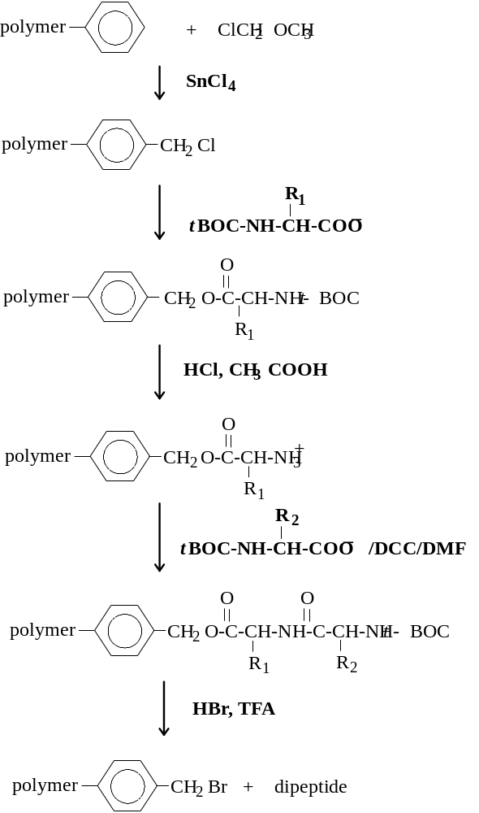

Enzyme Characteristics

Examples of metal ion requirements
Na intestinal sucrose α-d-glucohydrolase
K pyruvate kinase (also requires Mg)
Mg kinases: hexokinase, pyruvate kinase; ATPases-ATP hydrolases: myosin ATPase
Fe catalase, peroxidase, nitrogenase
Zn alcohol dehydrogenase, carboxypeptidase
Mo xanthine oxidase, nitrogenase
Cu cytochrome c oxidase, amine oxidase

Coenzymes

Pyridoxal phosphate | 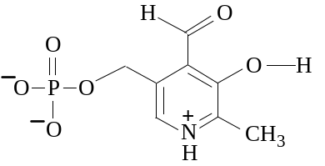 | as a Schiff base to a lysine residue in the apoenzyme | decarboxylation  transamination  racemization
biotin | 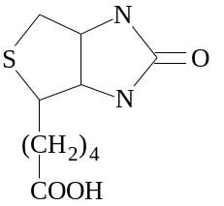
lipoic acid | 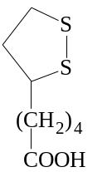
thiamin pyrophosphate | 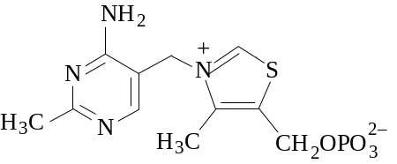
flavin adenine dinucleotide (FAD)  flavin mononucleotide (FMN) | 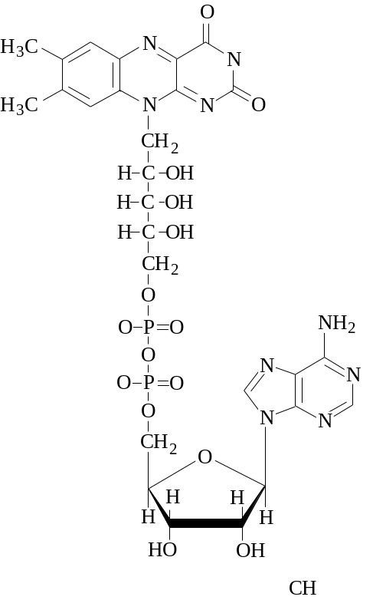
Folic acid | 